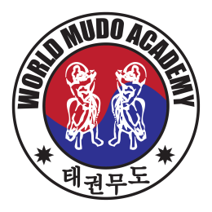
The Mudo Academy of Great Britain
Mudo Magazine June 2019
Welcome to The Mudo Academy of GB and Ireland.
The best time for new beginnings is now!
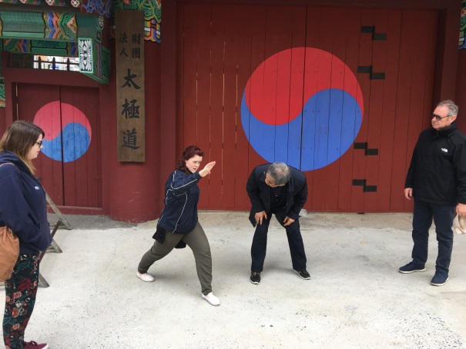
Title
Mudo Academy of GB visits South Korea :
The Mudo Academy of Great Britain visited South Korea on a tour of the whole of South Korea including training, ambassador work and sight seeing.
The Mudo Academy stayed as guests of Buyeo Temple where the students underwent special Gummudo training, furthering the knowledge gained from previous trips.
The students moved on to Daejeon, the fifth largest city in S.Korea.
Meetings were held with Professor Oh from Chung Cheong University. For my part I first met Professor Oh some 20 years ago at the World Mudo Academy Festival hosted by Chung Cheong and held at the University. At that same time Master(and Professor) Oh was awarded 8th Dan Blackbelt by Master Kim Yong Ho. After that event 20 years ago Professor Oh treated the senior blackbelts to a very entertaining evening and, we were not disappointed with the similar entertainment on this visit.
Professor Oh introduced us to Mr Park ,the Boeun County District Martial Arts Chairman. Mr Park who,s hospitality was no less than Professor Oh,s entertained very well,arranging for us to stay in a newly constructed Taekwondo Village ,consisting of all amenities along with traditional mountain accommodation.
Songni Mountain Village:-
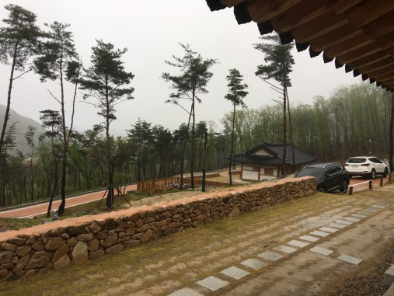 Traditional wood beams with underfloor heating and modern bathroom facilities.

Mr Park and Professor Oh went on to arrange meetings with the County Mayor, Mr Jung.
A loose agreement was made to hold an International Mudo Festival in Boeun-gun in October 2019 to coincide with the Ju Ju bean annual Festival. ( This arrangement was later ratified and will be going ahead as planned)
Professor Oh arranged for the visiting students to attend his dojang where some of his talented students performed a demonstration for the visitors benefit.
The visit was attended by the editor of the news outlet Newstown with their film crew.
Master Hannah Hatfield performed Palmudo Poomsae, Yongmu which was televised on local TV and also publicised in the local newspapers.

The students moved on to Busan where we were greeted by Master Jihyun and later by Master Woo ,two of The World Mudo Academy demonstration team members and students of Master Kim Yong Ho.
Busan is the second largest city in South Korea and is a marvellous coastal city with an amazing fish market, (it is more of an enormous street with hundreds of open air fish stalls selling every known thing that swims in the sea!)
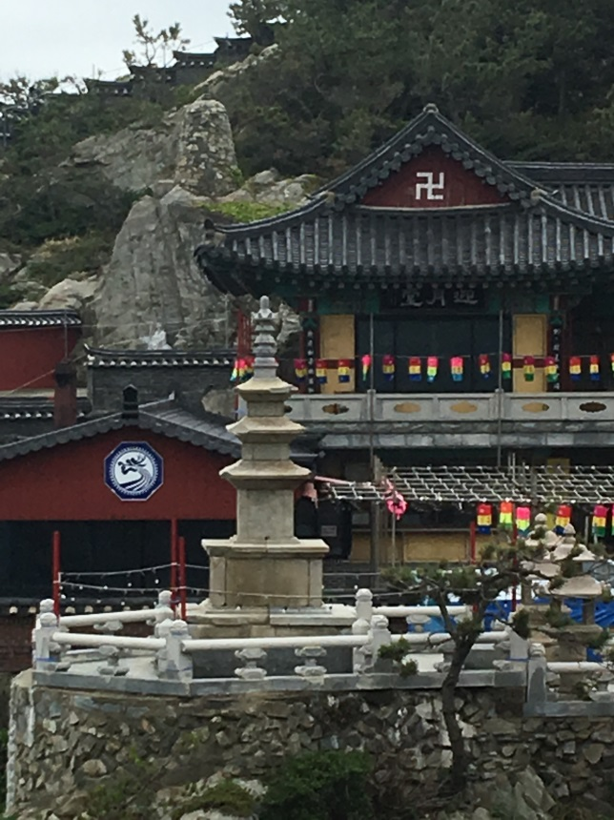

The students moved on via train to Seoul for the last few days.
Master Kim Yong Ho showed the students around Seoul to many areas not previously visited.
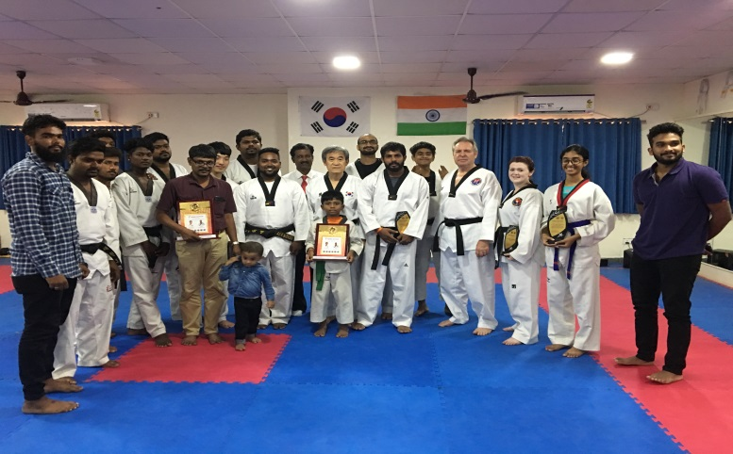
Master Kim showed me many areas where he had worked when he was in the Korean arm before,and after the Vietnam war. His position in Seoul was very important to the safety of South Korea at that time and consequently was a very famous ,if somewhat covert , man.

World Mudo Academy trip to India.
The World Mudo Academy visited India on an Educational Seminar trip.
First region on our tour was Chennai. Several Seminars were undertaken by Master Kim Yong Ho assisted by Master Kim Jihyun.
Master Ron Brennan and Master Hannah Hatfield started the teaching of the Paljungdo System which will be required for the Schools National Games introduction.
Next year 2020 the Mudo System will be introduced to the University games also.
The Seminars were hosted by Master Naveneth from Chennai.
The trip was very successful and we should receive good news by September this year with regards to major developments in the Chennai Region, related to the expansion of the Mudo Academy.

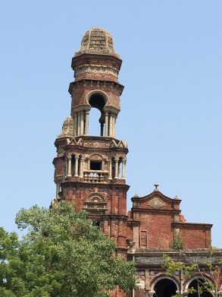
To stay updated go to http://www.mudoacademygb.com/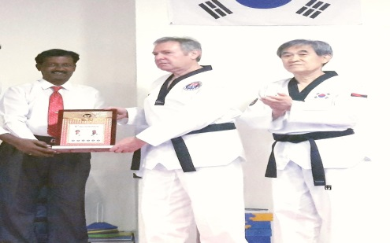

Gujarat ,India
We took a flight from Chennai to Mumbai and the overnight train to Gujarat .Our hosts were Masters Dharmendra Mistry and Sanjay Mistry of Hero Taekwondo Federation.

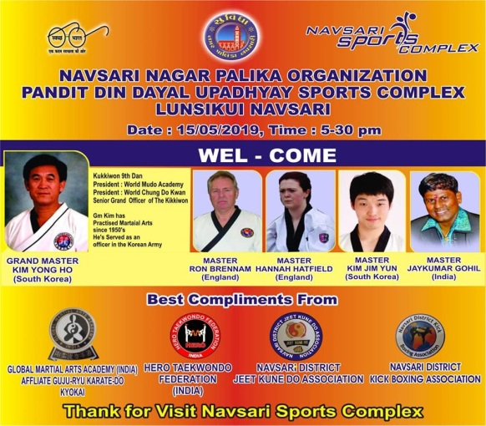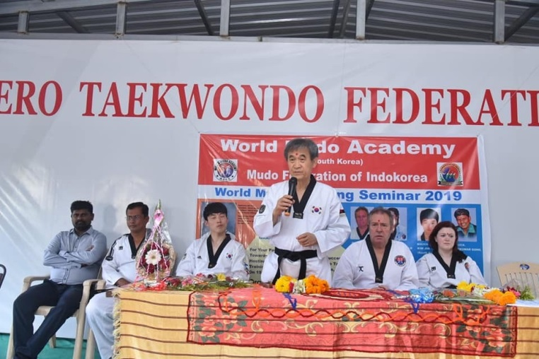

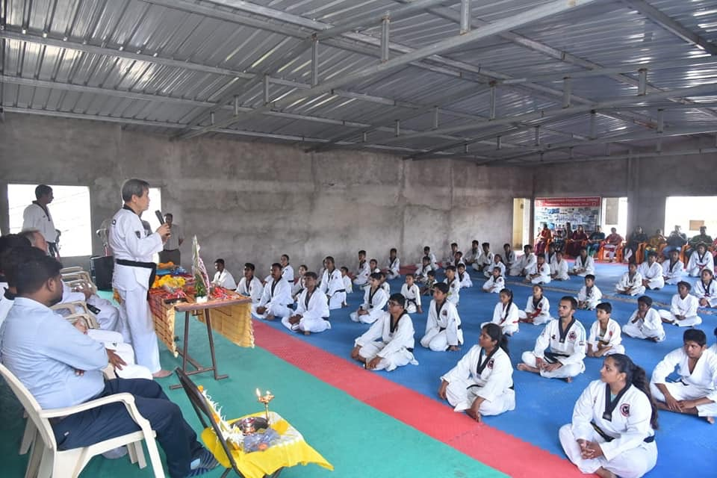

Many students and parents came to the seminar along with 7 Karate club leaders to hear Master Kim speak about the fundamental basis of the Martial Art and The Mudo Academy.

Mumbai India.

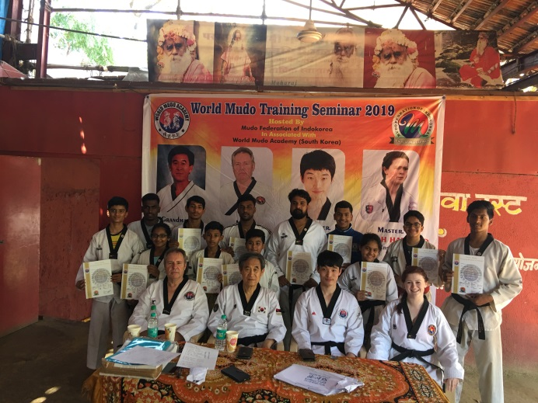 The Mudo Academy of Mumbai hosted by Jaykumar Gohil welcomed us to Mumbai where Master Kim held several seminars.
We were honoured also by a visit from the Mayor who has shown great interest in our work in Mumbai.

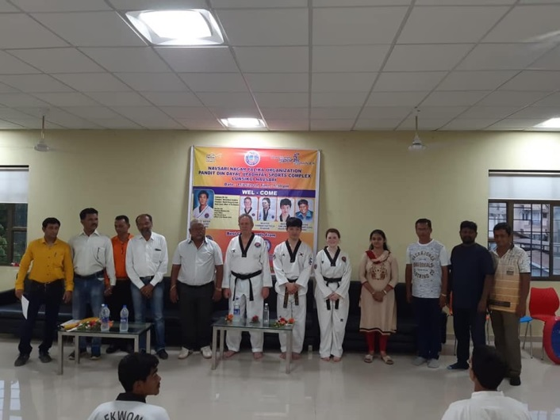 Proposals were launched to hold a major International Mudo Academy Festival/Competition in Mumbai in January 2020.
Plans are currently underway with more than 15 countries wishing to attend.
A team representing Great Britain will also be taking part.
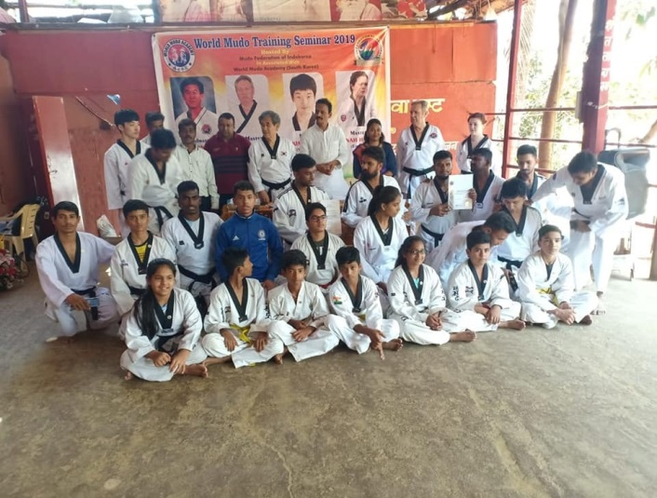 Proposals for the building of a central Mumbai Mudo Academy Dojang are also in the planning stage. We look forward to the expansion of The Mudo Academy in Mumbai in the near future.

Further News.

Master Kim will visit France-Switzerland-Belgium –Luxembourg- UK, holding seminars in all countries.
There will be an International Mudo Academy Festival hosted by Beon County South Korea in October 2019 to coincide with the JU-Ju bean Festival.
Master Kim will visit India again in August 2019 to galvanise relationships in the region of Chennai and Mumbai and to further plan for the up and coming International Festival.

New Products coming soon-
1. A new batch of Mudo Uniforms
2. Mudo belt buckles.
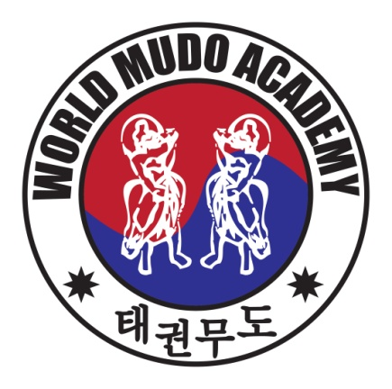

Mudo Shop
Price List
Mudo Academy Products Available:-
All About Taekwondo/Pal Jung Do £75.00
Mudo Academy Dobok £45.00
Embroidered Black belt (Master Kim Yong Ho) £30.00
Mudo Academy Gum with Cover £30.00
Mudo Academy Badge £3.50
Mudo Academy Metal Pin £3.50

Kim Chung Do Kwan Metal Pin £3.50
Kim Chung Do Kwan UK badge £3.50
Kim Chung Do Kwan Tracksuit Tops £45.00

Korean Red Ginseng:-

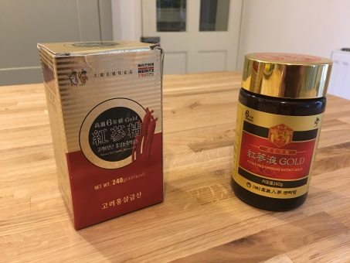 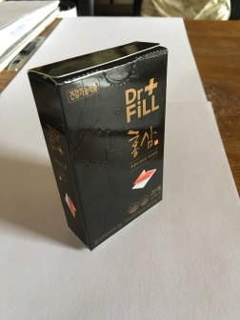 New Product:- Simply place on the tongue in the morning for your health and energy boost throughout the day.

Join the worldwide movement of

The World Mudo Academy
Anyone wishing to partake in these series or join the Mudo Academy of Great Britain and Ireland please contact:

Phone –
Email –
Application forms available as requested.

